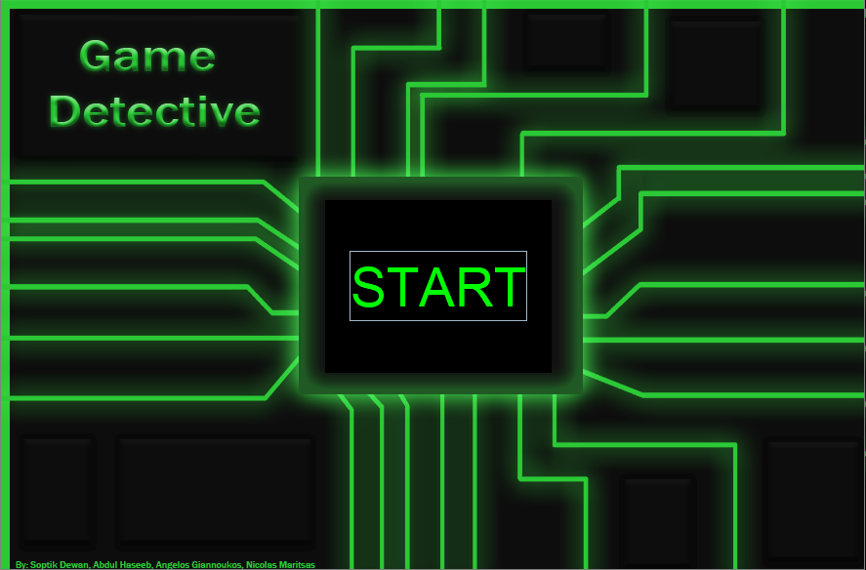

This is the Front Page and it comes up when the user loads up the program. There is only one function, The **ENTER** button which forwards you in the main menu of the program.

This is the Main menu which all the functions take place.

* The User can **Sort By Game, Genre, Price, Rating** of the games or **FIND BY NAME** which allows the user to type out the game they want to find.
* The User is able to **ADD** or **DELETE** games of the program

**Main Page:**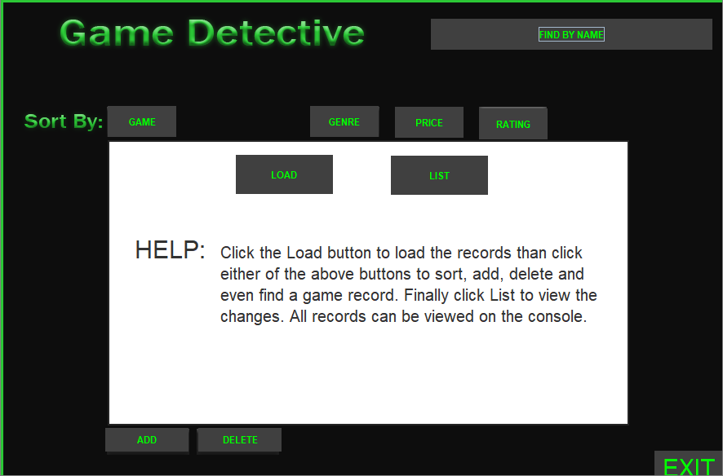

**Instructions**



**Make sure to click “Load” before doing anything else. The program will not function correctly otherwise.**



**Game:** It sorts the games alphabetically by their title. (Make sure to click “List” to view sorted records).



**Genre:** It sorts the games alphabetically by their genre. (Make sure to click “List” to view sorted records).

**Price:** It sorts the games from highest to lowest price. (Make sure to click “List” to view sorted records).

**Rating:** It sorts the games from highest rating to lowest based on their rating. (Make sure to click “List” to view sorted records). 



**ADD:** Allows the user to make their own record of a game. Using question prompts in the console.



Ex:



**Delete:** Allows the user to delete a game record by inputting the game’s title. (Case sensitive).

Ex: 

**FIND BY NAME:** Allows the user to search for a game by its name. (Case sensitive).

Ex: 



**Exit:** Allows the user to exit from the main window.